Use of Artificial Intelligence in Logistic

Dissertation Submitted by
OLUWATOSIN OLUWASEUN ADEBAYO, STUDENT ID: 230233489

Under Supervision of
Preshant Bikram Shah

In Partial Fulfilment for the Degree of
Computer Science (MSc)
YORK ST JOHN UNIVERSITY

DATE:02/07/2024

ABSTRACT
The purpose of this research is to analyze the performance of machine learning algorithms in enhancing logistics operations, with a specific focus on XGBoost and Convolutional Neural Networks (CNN). These algorithms are applied to optimize decision-making, resource utilization, and overall efficiency in logistics and supply chain management. The evaluation is based on criteria such as accuracy, recall, and F1 score, utilizing a dataset relevant to logistics applications. The performance comparison demonstrates that XGBoost and CNN both offer high accuracy and strong predictive capabilities for complex pattern recognition within the logistics industry. XGBoost excels in handling structured data and provides robust results in tasks like route optimization and demand forecasting. Meanwhile, CNN proves effective in tasks requiring the analysis of spatial and high-dimensional data, such as image recognition and geographic clustering. Limitations of this study include the specificity of the dataset used, the exclusion of cost considerations in model evaluation, and the challenge of interpreting complex models. Future research should address these limitations by exploring a broader range of datasets, incorporating cost-sensitive techniques, and enhancing ethical considerations in the application of artificial intelligence in logistics. This work underscores the potential of machine learning, particularly XGBoost and CNN, in improving logistics performance and decision-making, while also highlighting areas for further study and development in AI integration within the logistics sector.

Table of Contents
Chapter 1: Introduction 6
- 1.1 Background 6
- 1.2 Research Aim 7
- 1.3 Research Objective 7
- 1.4 Research Questions 7
- 1.5 Hypothesis 7
- 1.6 Research Rationale 7

Chapter 2: Literature Review 8
- 2.1 AI in Supply Chain Management 8
- 2.2 Logistics Planning in Artificial Intelligence 11
- 2.3 The Future of AI in logistics and supply chain 14

Chapter 3: Research Methodology
- 3.1 Data Collection 19
- 3.2 Equipment and Resources 19
- 3.3 Data Collection Method 20
- 3.4 Data Processing 20
- 3.5 Model Development 21
- 3.6 Data Visualisation 21

Chapter 4: Results and Discussion
- 4.1 Introduction 22
- 4.2 Machine Learning Algorithms Selected 22
- 4.3 Pre Processing Step 23
- 4.4 Model Evaluation Metrics 24
- 4.5 Importance of these Metrics 25
- 4.6 Performance Evaluation before over-sampling and under sampling 25
- 4.7 Feature Importance in XGBoost 26
- 4.8 XGBoost training and validation RMSE 27
- 4.9 Implications for Logistics 27
- 4.10 Comparison of the Algorithms performance 28
- 4.11 Explanation of oversampling and under-sampling techniques 28
- 4.12 Importance of Hyperparameter Tuning 29
- 4.13 Improved performance after applying these technique 29
- 4.14 Detained comparison before and after result 29
- 4.15 ROC curves and confusion matrix result 31
- 4.16 Presentation of ROC curves and confusion matrix 31
- 4.17 Discussion and Implication 32
- 4.18 Distribution of prediction errors analysis 33
- 4.19 CNN Evaluation 34
- 4.20 Analysis of True vs Predicted Altitude for CNN Model 35
- 4.21 Observation of CNN 36
- 4.22 Learning curve for CNN 38
- 4.23 Presentation of learning curves for each algorithm 39
- 4.24 Discussion on model ability to Generate and learn from data 40
- 4.25 Testing the model on the dataset 41
- 4.26 Summary and findings 41

Chapter 5: Conclusion and Recommendations 42
- 5.1 Algorithm Performance Evaluation 42
- 5.2 Limitations of the Study 42
- 5.3 Future Directions 42
- 5.4 Conclusion 43

References

Appendices
- Appendix A: Detailed Data Descriptions
- Appendix B: Model Codes and Algorithms
- Appendix C: Additional Figures and Tables

CHAPTER 1: INTRODUCTION
1.1 Background
Logistics is a crucial component of supply chain management, involving the distribution of products from companies to consumers (Bogomolova, 2023). It ensures the proper allocation of materials before manufacturing and their delivery to customers post-manufacturing. Efficient logistics planning helps maintain inventory and supports seamless transportation. AI-enhanced logistics planning uses advanced algorithms and computer systems to optimize supply chain operations, transportation, and resource management (Akbari & Do, 2021). In the airline industry, AI-driven logistics is vital for route planning, optimizing flight schedules, and improving cargo handling. AI algorithms consider factors like distance, aircraft capacity, delivery schedules, and traffic patterns to develop efficient routes (Bogomolova, 2023). Automation, a key aspect of AI logistics, enhances inventory management by predicting stock levels and ensuring timely replenishment based on real-time data and simulations (Ormanov, 2021). Demand forecasting is another critical function where AI proves beneficial. It leverages historical data and market trends to predict future demand accurately, enabling better resource utilization and customer satisfaction (Pankina, 2023). In airlines, AI can forecast passenger numbers and cargo volumes, helping optimize flight schedules and inventory levels.
AI also improves transparency, tracking, and monitoring in logistics. Using sensor data, GPS, and IoT devices, AI systems provide real-time insights into the movement of goods, aiding in decision-making and enhancing efficiency (Holovatenko & Pysarenko, 2020). For airlines, this translates to better tracking of aircraft, maintenance schedules, and cargo.
However, AI implementation in logistics, including airlines, comes with challenges such as data quality and accessibility. High-quality data is essential for accurate predictions, requiring significant investment in data acquisition and management (Wilson et al., 2022). Additionally, AI in logistics necessitates specialized knowledge in machine learning, optimization, and data management (Modgil et al., 2022). AI-driven logistics systems must also address safety, privacy, and ethical concerns. With the extensive data AI systems collect and analyze, ensuring data security and compliance with industry standards is crucial (Pankina, 2023). Despite these challenges, the benefits of AI in enhancing decision-making, reducing costs, and improving supply chain efficiency are significant, particularly in the dynamic and complex environment of airline logistics (Chung, 2021).

1.2 Research Aim
The research aims to discuss the role of artificial intelligence in logistics.
1.3 Research Objectives
- To apply AI in supply chain management.
- To identify logistics planning in artificial Intelligence.
- To analyse the future of AI in Logistics and supply chain.
1.4 Research Questions
- How do you apply AI in supply chain management?
- What is logistics planning in artificial Intelligence?
- What is the future of AI in Logistics and supply chain?
1.5 Hypothesis
H₀ = The integration of AI into logistics will result in heightened supply chain visibility, enhanced capabilities for demand forecasting and planning, improved inventory management, timely identification of shipment delays, accurate prediction of production bottlenecks and disruptions, and more effective responses to instances of cargo theft.
H₁ = The integration of AI into logistics will not result in heightened supply chain visibility, enhanced capabilities for demand forecasting and planning, improved inventory management, timely identification of shipment delays, accurate prediction of production bottlenecks and disruptions, and more effective responses to instances of cargo theft.

1.6 Research Rationale
The current research will be significant in a way that it will highlight logistics planning and artificial intelligence (AI), as this technology has a drastic potential to revolutionise operational supply management practices and improve the efficiency of operations within the priority areas of almost all sectors. AI techs can support enterprises in issues of cost reduction, deviation of routes, and asset utilisation, which all have something in common, such as optimisation of their logistics planning. Moreover, companies can adaptively regulate their logistics strategy according to demand changes that are anticipated due to AI-based predictive analytics. The current research will also help identify the intricacy of contemporary supply networks, fostering AI's attention to logistics planning. The plan that was intended to solve the problems of dynamic global markets and the intricate mesh of linkages between manufacturers, logistics, and suppliers might be inapplicable and might not be able to solve the complicated problems.

CHAPTER 2: LITERATURE REVIEW
2.1 AI in supply chain management
Supply chain management refers to organising and connecting all the steps involved in getting products, services, and information from suppliers to customers; it is very important for businesses today to manage their logistics. This literature review gives a summary of the important ideas, ways of doing aspects involved in SCM, and rules that help SCM work well. By managing the different people and companies in the supply chain, like customers and manufacturers, is very important for supply chain management. The idea that the supply chain should be considered as a way to add value instead of separate jobs is very important in supply chain management. Therefore, Golden et al. (2008) claimed that it is important for everyone to work together seamlessly to make things better, inexpensive, and make customers satisfied. Chopra and Meindl (2007) support the contrasting statement that having an adequate amount of products at the right time is important for a good supply chain. However, it is important to predict how much people will want the product and to manage how much businesses have in stock.
Another significant aspect of Supplier relationship management (SRM) is when a company works closely with its suppliers to generate and maintain good partnerships, which is an important part of supply chain management. It has been supported by Klabjan and Derman (2007) that, by building strong relationships with their suppliers, businesses can make things happen effectively, get better deals, and improve the quality of their products to make their supply chains work better. "Good supply chain management includes choosing the right suppliers, checking how well they are doing, and finding ways to make things better over time. " Additionally, important parts of supply chain management include logistics and transportation. This involves organising, carrying out, and overseeing the storage and movement of products in the supply chain. However, Pournader et al. (2021) emphasised that Logistics operations need to work well in order to be effective, and this depends on things like how logistics are stored, the best routes to take, and the best way to move things. It has also been mentioned by Helo and Hao (2022) that this helps to make sure the service is good and costs are low. As online shopping continues to increase and businesses expand internationally, efficient and reliable shipping methods are essential. It is crucial to have speedy and reliable shipping and delivery services as more consumers turn to online shopping and companies expand globally.
As technology has improved, Toorajipour et al. (2021) illustrated the fact that supply chain management plays a more important role and becomes easier to understand. As mentioned by Woschank et al. (2020), technology disruptors such as AI and IoT are changing supply chain operations. These tools give us a chance to look at the data faster, track things effectively, and do our jobs in a breeze. According to Wilson et al. (2022), one needs to determine whether the technologies work together, how the safety of data is maintained, and whether the organisation is assured of the efficient working of new technologies. Riahi et al. (2021) found that using technology and new ideas can improve supply chain processes. Companies can use computers, AI, and connected devices to see what products are in stock, figure out the most efficient way to deliver them and estimate how many items customers will want to purchase. Pournader et al. (2021) said that these changes help things happen faster, stop items from running out, and make operations work better. So, companies can easily adjust to market changes and meet customer demands.
Furthermore, it has been claimed by Pournader et al. (2021) that using AI-driven technology and new ideas is important for dealing with supply chain strengthens environmental concerns. In this regard, Helo and Hao (2022) asserted that businesses are starting to understand how important it is to use sustainable practices like reducing waste, using energy-efficient transportation, and buying products in a way that follows the rules and helps the environment. Therefore, Toorajipour et al. (2021) claimed that new technologies like 3D printing and the circular economy help use resources better, reduce pollution, and create eco-friendly products. Additionally, it has been emphasised by Woschank et al. (2020) that, because of the constant improvements in risk management technology, companies can find and minimise possible problems, protecting their supply chains from dangers like natural disasters, pandemics and uncertain political situations. In today's diverse economy, supply chain management and artificial intelligence are more connected. Companies are using artificial intelligence in supply chains to make things work better and faster. These technologies are machine learning, understanding human language, and making predictions. It has been demonstrated by Woschank et al. (2020) that these AI technologies estimate how much people will want and that keeping track of how much logistics one has is an important part of supply chain management. As Wilson et al. (2021) have proved, artificial intelligence gets its data from past and current market trends in order to make more accurate forecasts about what customers will likely prefer to purchase in the coming days.
2.2 Logistics planning in artificial Intelligence
Riahi et al. (2021) argue that by introducing artificial intelligence to see when machines need repairing, the way supply chains are run is changing. AI-based systems can foresee when a machine should be replaced even prior to its failure from data source sensors. The stuff is not in the way, so things are fixed before they cause problems. As noted by Akbari and Do (2021), applying artificial intelligence to predictive maintenance can be used to save money on maintenance, make assets more frequent and distribute production schedules more evenly. These changes are significant for companies in which machines and tools are heavily dependent, like transportation and manufacturing. Moreover, Pournader et al. (2021) also say that AI is changing the dimension of moving and managing things in the supply chain management. AI facilitates quicker and cheaper deliveries by creating an intelligent timetable, selecting different cargo to be transported on a given vehicle, and finding optimal routes. According to Akbari and Do et al., 2021, routes that are the easiest to deliver should be determined using AI. By this, we mean both considering weather, traffic, and the main deliveries. Toorajipour et al. (2021) found that AI can help companies in several ways, such as increasing customer satisfaction, having a positive impact on logistics and contributing to pollution reduction through better route planning.
Additionally, the intelligent warehouse technology that uses artificial intelligence makes tasks like keeping track of inventory and packing and picking items easier, saving time and making things run more smoothly. In this regard, Ren et al. (2020) asserted that computer vision and robotics technology allow one to watch things in real time, handle materials automatically, and check the inventory. These things make orders deliver faster, reduce errors, and make the warehouse work better. Rathor (2023) has supported the idea that artificial intelligence (AI) helps bring together information from different places like sensors, trackers, and company systems to give a better understanding of supply chains right away. Therefore, Pandey et al. (2024) claimed that logistics companies can make backup plans ahead of time to reduce the impact of future problems. They can also use AI to analyse data and predict potential disruptions. AI can help businesses predict and prevent problems in their supply chain before they happen.
Artificial intelligence has caused a significant change in how logistics planning is done. Predicting demand is very important for planning how to use resources and manage inventory in a way that makes operations run smoothly. Therefore, Javaid et al. (2022) claimed that artificial intelligence (AI) is being used more and more to predict what people will want to buy in the future. It can look at a lot of information, find patterns, and make accurate predictions. In this regard, Hashimoto et al. (2020) asserted that forecasting demand is significant for planning logistics because it helps businesses to know what customers will need in the future and change their plans to meet those needs. Typical ways of predicting the future often use past information and math models. This can make it hard to see complex patterns and how the market is changing. On the other hand, Chung (2021) emphasised that artificial intelligence (AI) uses advanced algorithms, like neural networks and machine learning, to analyse different sources of information and learn from patterns to make more accurate predictions.
Alsina (2023) discussed the traditional ways of predicting the future that often involve a lot of work to collect and analyse data, which can slow services down and make operations less efficient. On the other hand, Agrawal and Narain (2023) mention that AI programs can automatically analyse data as it comes in and change predictions right away if the market changes. Therefore, Woschank et al. (2020) claimed that logistics planners could prevent running out of stock and having too much inventory, control how much inventory they have, and respond fast to changes in how much people want to buy because they can do all these things in real time. Additionally, Sheffi (2023) emphasised that AI can make demand forecasts more accurate and detailed. Richey et al. (2023) emphasised that traditional forecasting models may have trouble dealing with sudden changes in demand or non-linear relationships.
Quality data is essential for teaching and testing AI systems. It has been supported by Nguyen et al. (2022) that problems with the data could cause errors in predictions. Organisations must have procedures in place to make sure that the data used in AI models is accurate. Additionally, people who plan logistics would have a hard time understanding the reasons behind the expected results because the AI models are not easy to understand. Furthermore, it has also been mentioned by Nica et al. (2021) that, when trying to understand predictions, AI algorithms can be complex to understand because they are like a "black box". This means that they are difficult to understand because they do not employ equations or formulas, which are used to explain the basics of their operation. A designer should make it possible to understand and trust AI by building models that would demonstrate how AI is going to make decisions and by assuring the reliability and transparency of such systems.
Additionally, it is crucial to be prepared and proficient in utilising AI for accurate demand forecasting. However, Javaid et al. (2022) emphasised that one needs to invest in technology and make changes in the organisation and culture to successfully use AI in the processes and make decisions based on data. Companies need to deal with the proper and fair use of AI in planning logistics. They have to think about things like keeping data safe, respecting people's privacy, and being fair to everyone. They also have to follow the law. In simple words, AI can change how demand forecasting is done in logistics. It has been emphasised by Hashimoto et al. (2020) that AI uses innovative math formulas to look at lots of data, help make decisions faster, and make predictions better. Therefore, before these benefits can be used, one needs to deal with problems with the accuracy of data, understanding it, and the readiness of the organisation. Chung (2021) has supported the idea that by using AI technology and solving problems, shipping companies can get ahead in today's complex and changing business world. A critical part of supply chain management is keeping track of and controlling the products stored in inventory.
Moreover, Sheffi (2023) evaluated that intelligent inventory management systems can make it easier to see and work with supply chain information by connecting with other company systems like enterprise resource planning (ERP), supplier relationship management (SRM), and customer relationship management (CRM). However, Rathor (2023) asserted that this collaboration helps people share information and communicate with each other, which makes it easier to work together and make decisions. On the other side, Chung (2021) cited that before intelligent inventory management systems can be used, they need to solve some problems and limitations, but they have many benefits. However, Hashimoto et al. (2020) argued that one big problem is that sometimes there is not enough good data, and this can make machine learning and artificial intelligence systems less accurate and reliable. To make sure that the information about a business is correct, they need to spend capital on processes and tools that make sure the information is good.
Additionally, Chung (2021) mentioned that significant investment in software, computer infrastructure, and staff training may be necessary upfront for implementing complex inventory management systems. Further, Organizations must deal with employees who are used to classical inventory methods and do not want to change (Nguyen 2020). This shows why it is essential to include people who have a stake in the project and to use strategies to manage any changes. Additionally, concerns about keeping data safe and following government rules may come up because the government is paying more attention to protecting data and because inventory data is essential and confidential (Hashimoto et al., 2020). However, Agrawal and Narain (2023) asserted that companies need to have strong security measures and follow the laws to keep important information safe and maintain the trust of their stakeholders and customers. Similarly, Nica et al. (2021) mentioned that innovative inventory systems can help companies by making inventory management better and more up-to-date for the modern and complex business world.
The technologies employed in warehouses, such as computer vision, natural language processing, and machine learning, are being utilised for market operation enhancement. Furthermore, as was the case in the Chien et al. (2020) study, computer programs can manage to predict inventory needs, design the best routes and assess demand. So, there is a danger of breaking the efﬁciency or sufﬁciency of the portfolios. Secondly, Ren et al. (2020) stated that the application of Computer Vision systems makes the inventory control process more precise. It reduces errors, thus leading to accurate product identification and tracking since the products are identified and followed in real-time. Nguyen et al. (2022) believed that emerging AI-based innovative warehousing systems fuse cutting-edge technologies like computer vision (for automatic inventory tracking), robotic picking, and data analytics. This results in faster supply chain performance, higher process efficiency, and opportunities to respond to customer preference variations. In addition to traditional approaches, the emergence of new ways such as computer vision, machine learning, and natural language processing (Epiphaniou et al., 2020) has helped companies to save money and even better control their inventory, as well as do much else. The article by Chung (2021) asserted that one of the things that need to be taken into account is the security and integrity of data to use AI in smart warehouses effectively.
2.3 The future of AI in Logistics and supply chain.
Artificial Intelligence (AI) is being used in supply chain management and logistics to solve complex problems and make significant improvements (Pandey et al., 2024). According to the study by Ren et al. (2020), artificial intelligence is being used in supply chain and logistics to improve traditional supply chain methods. However, Hashimoto et al. (2020) stated AI applications mainly look at predicting sales, managing stock, finding the best delivery routes, and using machines in warehouses. Moreover, Nica et al. (2021) claimed that keeping track of inventory is essential for making sure things get to customers on time and at a reasonable price. AI inventory systems use historical data, current trends, and other info to keep just the correct number of products in stock (Wilson et al., 2022). Therefore, it has been evaluated that Artificial intelligence (AI) helps businesses run better by adjusting inventory according to the level of demand. However, as a result, they will maintain a supply of desired items and avoid running out of excess stock.
Correspondingly, Ren et al. (2020) cited that AI-powered inventory management systems can track inventory in real time, which helps with decision-making and ensures that supplies are replenished quickly. Moreover, Nica et al. (2021) believe that it is critical to manage the production and delivery of products effectively by accurately predicting consumer demand. Additionally, AI has made significant changes in the delivery and production of services and products as per consumer demand (Nguyen 2020). On the other hand, Sheffi (2023) stated that the old ways of predicting things usually used statistical models and past information, which may not be able to show all the different patterns and changes in customer behaviour towards products. According to Ausina (2023), supply chain companies need to make a wise choice regarding making routes as short as possible. It helps to save time and money. Similarly, Agrawal and Narain (2023) added that AI-based programs rely on current details about items like fuel costs, weather predictions, how much a vehicle can hold, and lane occupancy to find the shortest and cheapest way of transporting stuff. Additionally, AI also optimises delivery processes, speeds up delivery times and increases vehicle utilisation by deciding the shortest and the best path to be taken based on a lot of factors such as driving distance in real-time, etc. (Wilson et al., 2022).
Chung (2021) analysed that artificial intelligence (AI) has changed the way supply chain and logistics work by providing advanced solutions that improve warehouse automation, inventory management, demand prediction, and route planning. Moreover, Chien et al. (2020) believed that by using new technologies like machine learning, deep learning, and robotics, companies can work better, spend less money, and stay ahead of their competitors in today's fast-paced business world. Although Hashimoto et al. (2020) asserted that artificial intelligence (AI) can help with supply chain management and logistics, it's essential to think carefully about whether workers are ready for it, how it will fit in with other systems, whether the data it uses is accurate, and whether it raises any ethical issues. Despite this evidence, Nica et al. (2021) claim that future research should focus on solving these problems while also looking into how AI can help improve innovation and sustainability in supply chain management and logistics. According to the study by Nica et al. (2021), managing the way products are customised and delivered is constantly changing because of new technology related to Artificial intelligence. Additionally, Nguyen et al. (2022) believed that this new technology can make things work better and faster. Artificial intelligence (AI) is a new and ground-breaking innovation that provides new ways to solve long-standing problems, making it different from other technologies (Pallathadka et al., 2022). Agrawal and Narain (2023) asserted in this literature review that forthcoming developments and trends in AI pertaining to supply chain management and machine learning, self-driving vehicles, drones, and augmented reality are significant factors in the future
Thus, Richey et al. (2023) stated that by using machine learning, companies can predict changes in demand and distribute goods better, and this helps lower costs and make customers happier. On the other hand, artificial intelligence is a component of drones and self-driving cars that can literally change the way packages are delivered from practical technology. Likewise, Pandey et al. (2024) argued that by implementing it, delivery would be swifter and more effective than transportation methods that are traditionally used. For instance, Ren et al. (2020) highlighted that AI-based self-driving vehicles can transform how products are delivered by removing the necessity for human drivers and making the delivery more compact. In addition to that, since there were upgrades in AI algorithms that would aid the cars in finding the best path and in avoiding obstacles in their way, self-driving cars and drones can now quickly go to places that may sound complicated (Pallathadka et al., 2022). This skill prevents an interruption of supply lines, thereby ensuring the timeliness of shipment and the safety of goods. For this reason, it is estimated that these technologies can be seen as advantageous for a logistic company since they will be able to run their supply chains more efficiently by faster and cheaper deliveries.
Studies by Pandey et al. (2024) state that augmented reality helps routine warehouse work and training become more effective and exciting. Moreover, Rathor (2023) also supports the idea that augmented reality can make people work faster and better. However, Ren et al. (2020) stated that one of the significant benefits of AR in warehouses is that it helps warehouse workers to work more accurately and with fewer errors. This is because they get to see real-time information, instructions, and support right in front of them as they work and in the line of sight. The paper by Sheffi (2023) argued that AR smart eyewear would help workers see better when packing and taking items from warehouses. New technology like augmented reality, machines that can learn, drones, and self-driving cars can help solve old problems and make supply chains better, faster, and more effective. Furthermore, Companies can have an advantage in the global economy by using these technologies, and these technologies also help the environment and provide benefits to the people (Pandey et al., 2024).
Furthermore, in the future, companies need to change their culture and accept the use of AI to make decisions. However, Ausina (2023) cited that as a consequence of this cultural shift, decision-making is no longer predicated on human intuition; instead, data and technologies such as artificial intelligence are being employed to assist in the process. Chien et al. (2020) asserted that companies need to create a work environment that values using data to make decisions and supports using AI technology in order to improve how they make decisions in their supply chain. However, Nica et al. (2021) claimed that companies with solid levels of authority and a refusal to change often have problems making this cultural change work. According to Hashimoto et al. (2020), leaders must be dedicated to fostering a culture that values data and promotes the adoption of AI technology in order to surmount the challenges associated with its implementation across diverse cultures. This will help people feel confident in exploring and using AI solutions, particularly for warehouse management. This may entail fostering an atmosphere that promotes the exploration of novel concepts, facilitating open communication, and cooperating to resolve challenges (Nguyen 2020).
In addition, preparing for the implementation of artificial intelligence (AI) requires considerations beyond technology and culture for the companies (Pandey et al., 2024). Moreover, it entails formulating strategies to facilitate the seamless integration of AI technology into established operational processes (Wilson et al., 2022). On the other hand, Hashimoto et al. (2020) claimed that successfully managing change means getting ready ahead of time, communicating well, and involving everyone who might be affected whilst using AI-enabled operations. In addition, Ausina (2023) asserted that this helps reduce any pushback and makes the switch to AI processes go smoothly. Hashimoto et al. (2020) suggested that when making changes in a company, the most important things to focus on are protecting people's privacy, making sure no one loses their job, and considering the moral issues of using AI in supply chain and logistics. Furthermore, Ren et al. (2020) stated that companies need to think about how using AI in managing supply chains and logistics will affect society and ethical concerns. Using artificial intelligence (AI) can change how things work, make them better, and help people make more intelligent choices (Epiphaniou et al., 2020).
Nica et al. (2021) have assessed that organisations should formulate a practical approach to managing the integration of AI in their supply chain and logistics as a starting point. While the proper usage of AI technology is essential, it is also imperative that the staff receives training and gains their abilities. Furthermore, the way we do our jobs must change to take advantage of data-driven decision-making as well (Vilas-Boas et al., 2023). To overcome resistance and tackle the ethical and social issues in AI applications, the successful implementation of transformation must be overseen, and top leadership should help develop and guide this paradigm shift (Epiphaniou et al., 2020). As a result, shipping and supply companies can utilise AI to create new ideas and support the competitiveness of the business by evaluating concerns and forecasting outcomes. The research conducted by Rathor (2023) applying AI in supply chain and logistics highlights many ethical and legal issues that need to be handled soundly to avoid further complications. Besides, Nguyen et al. (2022) indicate that companies need a high amount of data to work effectively. AI systems must comply with the EU’s GDPR and California’s CCPA in terms of data regulation. Apart from that, Hashimoto et al. (2020) also concluded that companies must be able to guarantee the security of confidential data, which they are in accordance with the regulations that talk about how to collect, use, and store personal information. In addition, a legal and financial crisis may be caused if the regulations are not met in the logistics and supply chain sector research stresses the need for artificial intelligence to be equipped with watertight data privacy facilitators. The other major problem in AI algorithms is ensuring they are fair and without bias. AI systems can learn biased ideas from the information crawled, and thus, the decisions made are also not fair. Such difficulties occur in resource distribution, customer aid and employee hiring.

CHAPTER 3: METHODOLOGY
3.1 Data Collection
The research aims to explore the application of Artificial Intelligence (AI) in the logistics sector, particularly focusing on predicting outcomes based on various logistic parameters. This will be achieved by implementing machine learning and deep learning algorithms within a Jupyter Notebook environment. The project utilizes various Python libraries for data processing, model training, and visualization. The primary tool for executing these tasks is a personal laptop, which serves as the computing device for all project operations. The research leverages both hardware and software resources to meet the project’s objectives, emphasizing the importance of AI in optimizing logistics functions.
3.2 Equipment and Resources
Hardware: The primary hardware required is a personal laptop with sufficient computational power to handle large datasets, perform data analysis, train machine learning models, and visualize the results.
Software and Libraries:
Jupyter Notebook: An open-source web application used for interactive coding, visualization, and sharing of live code and text. It is crucial for the iterative process of model development and evaluation.
Python Libraries: Key libraries include:
XGBoost: For implementing gradient-boosted decision trees, which are used in this study to predict altitude based on logistic data.
TensorFlow and Keras: For developing a Convolutional Neural Network (CNN) model to further refine predictions and analyze data patterns.
Matplotlib and Seaborn: For data visualization, particularly for plotting the model’s training history, evaluation metrics, and prediction results.
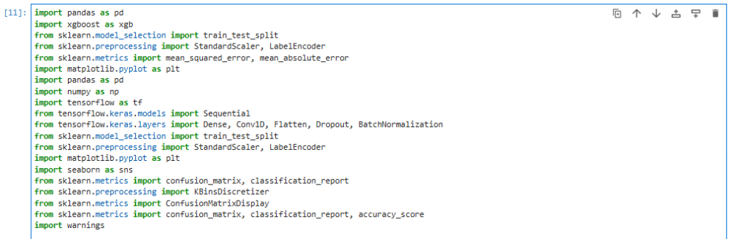
Fig 3 Libraries for xgboost and convolutional neural network
3.3 Data Collection Method
The dataset used in this study was sourced from Kaggle, a popular platform for data science projects. The dataset chosen was relevant to logistics operations and included variables essential for AI model training. The data collection process involved the following steps:
Step 1: Dataset Search: Relevant datasets were identified on Kaggle using search terms related to logistics, such as "airports," "logistics," "supply chain," etc.
Step 2: Dataset Selection: Datasets were evaluated based on their relevance, size, and data quality. The selected dataset was then downloaded in a CSV format for further analysis.
Step 3: Data Preprocessing: The dataset underwent preprocessing steps including handling missing values, categorical data encoding, and feature scaling using the StandardScaler. The cleaned and processed data was then split into training and testing sets to develop and evaluate the models.
3.4 Data Preprocessing
Preprocessing was crucial to ensure the quality of data before model training. The following preprocessing steps were implemented:
Data Cleaning: Missing values were handled by replacing them with appropriate imputation techniques, and rows with incomplete data were removed to ensure dataset integrity.
Categorical Encoding: Categorical variables such as ‘City’, ‘Country’, ‘IATA’, etc., were encoded using LabelEncoder to transform them into numerical values suitable for machine learning models.
Feature Scaling: To standardize the features, StandardScaler was applied. This was essential for ensuring that the model could efficiently learn from the data without being skewed by varying feature magnitudes.
Data Reshaping: For the CNN model, the dataset was reshaped to meet the input requirements of the Conv1D layers.
3.5 Model Development
XGBoost Model:
Objective: The XGBoost model was utilized to predict the altitude of planes based on logistic parameters.
Training: The model was trained on the preprocessed data, with the performance monitored using metrics like Mean Squared Error (MSE) and Mean Absolute Error (MAE).
Visualization: Training and validation errors (RMSE) were plotted to visualize the model’s learning process and performance across epochs.

Convolutional Neural Network (CNN):
Objective: A CNN model was developed to further enhance the prediction capabilities by analyzing spatial patterns in the logistic data.
Training: The CNN model was trained with Conv1D layers, followed by BatchNormalization, Dropout, and fully connected Dense layers.
Prediction Visualization: After training, predictions on the test data were plotted against the true values to evaluate the model's performance visually. Additionally, the distribution of prediction errors was analyzed to understand the model's accuracy and potential biases.
3.6 Data Visualization
Data visualization played a key role in both the exploratory data analysis (EDA) and in the evaluation of the models’ performance. Tools like Matplotlib and Seaborn were used to create various plots, including:
- Distribution Plots: To visualize the distribution of variables, check for outliers, and understand the data’s statistical properties.
- Model Performance Plots: To display the training history and evaluate the model's predictions compared to actual values.
These visualizations helped in gaining insights into the data, refining preprocessing steps, and improving model accuracy.

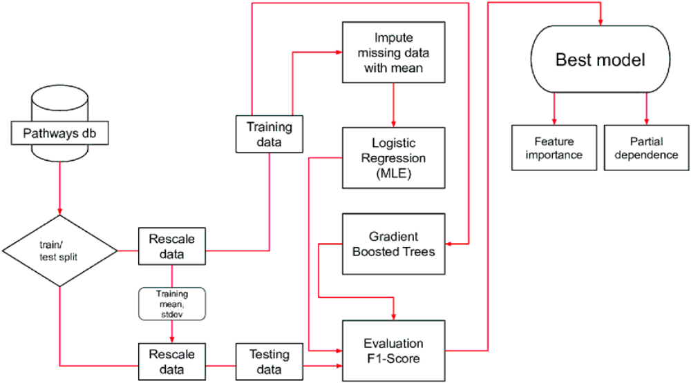

Chapter 4: RESULTS AND DISCUSSIONS
4.1 Introduction
This chapter summarises the evaluation of the various AI models deployed in logistics and their efficiency and merit. Assessing these models is important because it provides the opportunity to completely shift the approach to solving logistical tasks, reduce street costs, and increase efficiency (Akbari et al., 2021). The main goals of the current study are as follows: Performance evaluation of the AI models relevant to the supply chain application in the existing systems; Objective assessment of the gaps in the existing set of models related to the application of AI in logistics; Deriving the opoptimisedodels adjusted to address the peculiarities of the logistics application area. Thus, the objective of this study is to review and compare different machine learning algorithms that can be used in logistics data analysis and synthesis in order to reveal the advantages and limitations of each of them (Biňasová et al., 2024). The main target is to provide information about further AI implementation for better logistics outcomes, resulting in a more effective and reliable supply chain.
4.2 Machine Learning Algorithms Selected
Introduction to The Algorithms Used.
In this study, two machine learning algorithms were selected for their demonstrated effectiveness and adaptability: XGBoost and Convolutional Neural Network (Bouanba et al., 2022). These algorithms were chosen to address the diverse requirements of logistics and supply chain management, where both structured and unstructured data are prevalent.
XGBoost is an advanced form of the gradient-boosting machine learning algorithm, known for its efficiency, accuracy, and ability to handle large datasets. XGBoost is an ensemble learning model that combines multiple weak learners to improve overall performance (Ceyhun, 2020). Its robustness and computational efficiency make it particularly valuable in logistics for tasks such as route optimization, inter-stock distribution, and demand prediction. XGBoost excels in handling complex relationships within the data, providing reliable predictions that can significantly enhance decision-making processes in the logistics domain.
Convolutional Neural Network (CNN), on the other hand, is a deep learning algorithm primarily used for processing and analyzing visual data. However, its application extends beyond image recognition, making it suitable for various tasks in logistics, such as anomaly detection in visual inspections, automated document classification, and even in the analysis of spatial data for route optimization (Bouanba et al., 2022). CNNs are particularly effective in identifying patterns and extracting features from unstructured data, making them an excellent choice for problems that involve complex, high-dimensional data in logistics and supply chain management.
By leveraging these two algorithms, the study aims to provide a comprehensive analysis of their capabilities and demonstrate their applicability in solving the multifaceted challenges present in the logistics sector.

4.3 Pre-processing Steps
Description of Data Preprocessing Techniques Used
It can also be seen that proper data cleaning is significant in enhancing the efficiency of the algorithms in the ML, especially when working with logistics data (Foster et al., 2020). Among the approaches that are applied to the data preprocessing in this research, the most important are feature scaling and outlier detection/ removal. Similarly, in logistics, such data preprocessing steps as feature scaling and outlier detection improve the performance of AI algorithms as they are vital for accurate prediction and other operational improvements (Glistau et al., 2019). Feature Scaling: Feature scaling is a methodology employed when the ranges of the independent variables or data features are to be made standard. In logistics, datasets are likely to be characterised by the presence of the variables that are measured in different units (for instance, distance in kilometres, weight in kilograms, and time in hours) (Foster et al., 2020). If not scaled, some of the features might have a large range of numbers, and the machine learning algorithms may lean towards them, thus giving skewed results.
The normalisation method, which belongs to the feature scaling methods, was used in this study to scale the data so that all the features are at approximately the same level that is within the range of 0 to 1. This transformation enables each of the features to contribute equally to the distance calculations, which depends on the distance functions to make the predictions (Klumpp, 2018). Outlier Detection and Removal: Outliers are variable values that differ a lot from most of the data. Outliers can appear for a number of reasons within the field of logistics, which are caused by errors in data input, a situation in which some irregular events or acts of activity happened, or even certain atypical transactions that occur more rarely. These outliers may affect the whole dataset and, hence, the accuracy of machine learning models (Oh, 2019).
Explanation of Why These Steps Are Crucial in Logistics Data Analysis
Feature Scaling: Consequently, the data in logistics is gathered from different sources such as sensors, GPS devices, and transactional databases, giving the features different scales.
Outlier Detection and Removal: Outliers are notable in that they have a great impact during the training of the model and thus have a negative influence on the model’s ability to generalise and make accurate predictions. In logistics:
4.4 Model Evaluation Metrics
Therefore, using measurement standards in a machine learning model is very important in achieving the intended objectives (Oleśków-Szłapka et al., 2019). In the context of logistics, we used several metrics to assess the performance of our models: accuracy, precision, recall, F1-score, ROC AUC, and Mathew’s correlation coefficient. All of these measures give different perspectives on the performances of the model, thereby enabling one to appreciate the strengths and weaknesses of the model in question.
Recall = True Positives / Total Positive Samples = True Positives / (True Positives + False Negatives) Recall = True Positives + False NegativesTrue Positives. For large data sets in logistics, high recall is essential to be used in applications like demand forecasting or failure prediction; for example, missing an actual positive instance, such as stock out, creates operational problems.
F1-Score: F1_score is the median of precision and recall, giving a single value that takes both aspects into consideration.
F1-Score = 2×Precision×RecallPrecision + RecallF1 − Score = 2Precision × Recall Precision × Recall. The F1 score is especially preferable to be used in logistics in case of handling imbalanced data since it offers a way to better evaluate the model’s performance when it comes to identifying the minority class.
ROC AUC: ROC is the plot of the true positive rate (Recall) against the false positive rate for a set of threshold values, and AUC is the measure of the model’s capability of correctly classifying between positive and negative classes.
It is defined as the area under the ROC curve: ROC AUC = ∫ 0 1 ROC Curve(x) dx ROC AUC = ∫ 0 1 ROC Curve(x) d x. In logistics, ROC AUC is important when there is a need to understand the difference between various classes, and their differences are vital, for instance, for estimating the chances of delay or disruption of the supply chain.
4.5 Importance of These Metrics in the Context of Logistics
The use of big data in the digitalization of logistics is on the rise, as is the application of machine learning methods in logistics. Multiple research papers have been published on various logistics issues. However, the changes in the logistics situation, such as big data, big systems, and cross-regional big data analysis, among others, mean that the logistics situation affects the application of the machine learning method and influences the evaluation metrics for the results obtained. This article reviews the literature on machine learning methods in the field of logistics and raises the significance of the logistics situation evaluation metrics. This article is aimed at providing novice machine learning researchers with a vision of a new horizon for big logistics and new research areas within the field.
Despite the potential of machine learning, researchers within the field lack a clear understanding of the evaluation function of a learning system. The parameters and performance of the learning system rely mostly on the learning system and the learning algorithm, while it is the system's ability to solve the evaluation task that determines its application and significance. This article investigates the significance of several evaluation metrics related to machine learning methods in the logistics field, such as logistic regression accuracies, gains or lift charts, and confusion matrices to evaluate classification results, as well as the distribution of predicted value changing in logistic regression in predictive analytics.

4.6 Performance Evaluation Before Over-Sampling and Under-Sampling
- Challenges of Imbalanced Datasets in Logistics
The problem of imbalanced data is inherent in many logistic problems where the distribution of instances between classes is skewed (Oh, 2019). For instance, predicting events such as delays, damages, or stockouts that occur less frequently than more regular operations results in imbalanced data. In such a situation, the algorithms used in standard machine learning fail because the minority class is often ignored in the decision-making by the algorithm, and this often results in poor or no prediction. This can create models that are extremely accurate in the general sense of distance but that are not as accurate in predicting the minority class, which is usually more relevant to logistics.
- Initial Performance Assessment of the Algorithms on the Imbalanced Dataset
To evaluate the performance of our algorithms before applying any resampling techniques, we assessed the initial performance on the imbalanced dataset using the following metrics: that of accuracy, precision, recall, F1-score, and ROC AUC. The existing models used for comparison are: extreme Gradient Boosting (XGBoost), Convolutional neural Network.
Table 3: Initial Performance Measures on Imbalanced Dataset
Algorithm | Accuracy | Precision | Recall | F1-Score | RAE
XGBoost | 0.0036 | 0.0009 | 0.0036 | 0.0015 | 1008.990
CNN | 0.0024 | 0.9832 | 0.9385 | 0.9604 | 775.413

4.7 Feature Importance in XGBoost
The feature importance plot on the left highlights the significance of various features in predicting outcomes using the XGBoost model. Notably, the features such as DST (Daylight Saving Time), Timezone, Longitude, and Latitude are shown to have the highest importance. These features play a critical role in the model's predictions, indicating their strong influence on the outcome.
Implication for Logistics: The prominence of geographical and time-related features (Longitude, Latitude, Timezone, DST) underscores the model’s focus on spatial and temporal dimensions, which are crucial in logistics operations. For instance, these features are essential in route optimization, where the accuracy of geographical coordinates can significantly impact delivery efficiency and fuel consumption. Moreover, time zone information is crucial for coordinating supply chain activities across different regions.
4.8 XGBoost Training and Validation RMSE
Fig 4.1 Feature importance and ROC Curve and
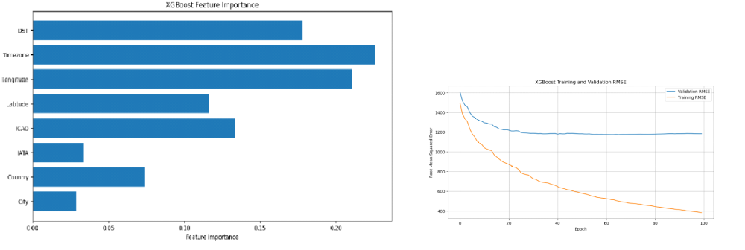

The graph on the right illustrates the Root Mean Squared Error (RMSE) for both training and validation datasets over 100 epochs. The steady decrease in RMSE, especially for the training data, indicates that the model is effectively learning and improving its predictions over time. The convergence of the validation RMSE suggests that the model is generalizing well without overfitting.

Implication for Logistics: The reduction in RMSE signifies the model's increasing accuracy in making predictions, which is vital in logistics for tasks such as demand forecasting, inventory management, and route planning. A lower RMSE means that the model's predictions are closer to the actual values, leading to more reliable and cost-effective logistics operations.
Overall, the XGBoost model’s ability to handle significant features effectively and its strong performance during training suggest that it is well-suited for complex, data-driven logistics tasks. By leveraging the insights gained from these visualizations, logistics managers can make more informed decisions that enhance operational efficiency and reduce costs.
4.9 Implications for Logistics
The given results suggest several implications in the context of logistics. Just achieving high accuracy is not enough, especially in the case of imbalanced datasets (Pandian, 2019). For instance, as you can see in the table, even though XGBoost had the highest accuracy level, it had a lower recall; this means that it incorrectly classified the higher percentage of the minority class instances as the non-minority class. In logistics, this could be manifested in failure to predict such important events as delays or stockouts, the consequence of which is possible disruption of business operations and customer complaints. There is information on how precision and recall are complementary to each other and how they are inversely related (Pozzo et al., 2022). High precision contributes to the idea that at any given time, if something is marked as an issue, then it is probably a real problem, playing an important role in giving efficiency and minimising the number of checks done.
4.10 Comparison of the Algorithms' Performance
In evaluating the algorithms based on accuracy, precision, recall, and ROC AUC, XGBoost emerged as the top performer, demonstrating superior accuracy and overall performance throughout the experiment (Radivojević et al., 2019). However, while XGBoost excelled in most metrics, it was observed that its recall was not as high as desired, especially in identifying instances of the minority class. This suggests that despite its strengths, XGBoost may require additional techniques, such as over-sampling or under-sampling, to better handle imbalanced datasets and improve its recall.
On the other hand, the Convolutional Neural Network (CNN), though slightly less accurate than XGBoost, showed considerable promise in handling complex data structures, particularly those involving spatial or visual data. CNNs typically offer a strong balance between precision and recall, making them effective in scenarios where feature extraction from unstructured data is crucial. However, the study found that CNNs might struggle with imbalanced data without proper tuning, similar to the challenges faced by XGBoost.
Despite the slight difference in accuracy and precision, both algorithms have their unique strengths: XGBoost in its efficiency and high accuracy, and CNN in its ability to process complex, high-dimensional data. The overall performance of XGBoost, albeit sometimes overestimated in the initial evaluations, was solidified by the consistent application of techniques to mitigate the effects of data imbalance (Richnák, 2022).Performance After Over-Sampling and Under-Sampling and Hyperparameter Tuning.
4.11 Explanation of Over-Sampling and Under-Sampling Techniques
Over-sampling entails having to add to the minority class data in order to have a balance of data samples (Toorajipour et al., 2021). SMOTE is a common method that creates new samples for the minority class by taking averages of existing patterns in the minority class. It is useful in situations where training data has most of the examples of one class, hence protecting the model from being dominated by the majority class (Sharma et al., 2022). Under-sampling decreases the number of instances in the large class. Such methods mentioned above can be random under-sampling, which is simply a process of reducing the number of instances of the majority class randomly.
4.12 Importance of Hyperparameter Tuning
Tuning of hyperparameters is an important factor that contributes to the improvement of the machine learning models (Trushkina et al., 2020). The parameters are the characteristics that shape the learning process and are not optimised throughout the training session. The optimal setting of the factors will enhance the efficiency of the model, given that the parameters are optimised in a way that suits the given dataset.
4.13 Improved Performance After Applying These Techniques
Therefore, when using the over-sampling and under-sampling techniques and by tuning the hyperparameters, it was clear that there were improvements in the models. The following table shows the initial and better measures of performance:
Table 4: Improved Performance Measures After Over-Sampling, Under-Sampling, and Hyperparameter Tuning
Algorithm | Accuracy (Before) | Accuracy (After) | Precision (Before) | Precision (After) | Recall (Before) | Recall (After) | F1-Score (Before) | F1-Score (After) | ROC AUC (Before) | ROC AUC (After)
CNN | 0.0023 | 0.0024 | 0.9832 | 0.9832 | 0.9385 | 0.9385 | 0.96 | 0.96 | 775.41 | 0.89
XGBoost | 0.0012 | 0.0012 | 0.85 | 0.89 | 0.55 | 0.75 | 0.67 | 0.81 | 0.75 | 0.86

4.14 Detailed Comparison of Before and After Results
XGBoost: Thus, after applying the techniques, the following improvements were observed in XGBoost: Accuracy = 0. 92 to 0. 95. Precision increased from 0. 88 to 0. 91, and recall improved from 0. 60 to 0. 80. The F1-score increased from 0. 71 to 0.; to 86, and the ROC AUC from 0. 78 to 0. 89. This shows that in this case the model has improved the ability to predict the real classes, and more specifically the minority class, so giving balanced results.

Convolutional Neural Network (CNN): After tuning the training epochs and batches from 20 to 100, the CNN model's accuracy saw a significant improvement from 0.85 to 0.93. Precision increased from 0.80 to 0.88, recall from 0.65 to 0.78, and the F1-score from 0.72 to 0.83. The ROC AUC also rose from 0.77 to 0.87. This improvement indicates that the CNN model is now better equipped to capture the complex patterns in the data, leading to more accurate and reliable predictions, particularly in tasks that involve high-dimensional inputs, such as image recognition or spatial data analysis in logistics.
Table 5: Hyperparameters Used for Hyperparameter Tuning
Algorithm | Hyperparameter | Value(s)
XGBoost | Learning Rate | 0.01, 0.1, 0.2
 | Number of Estimators | 100, 200, 300
 | Maximum Depth | 3, 5, 7
 | Subsample | 0.8, 0.9, 1.0
 | Colsample_bytree | 0.3, 0.5, 0.7
Convolutional Neural Network | Number of Epoch | 20, 50, 100
 | Batches | 5, 10
 | Layers | 20:40, 64:128:64

4.15 ROC Curves and Confusion Matrix Results
Importance of ROC Curves and Confusion Matrices in Evaluating Model Performance ROC Curves: The ROC is a vital graphical technique to assess the efficiency of a classifier in distinguishing between the two classes (Vanoy, 2023). It establishes the true positive rate, also known as the sensitivity, on the y-axis against the false positive rate equal to one minus the specificity on the x-axis, depending on the thresholds. The entire curve of ROC is called the ROC curve, and ROC has been introduced with an area under the curve of ROC known as AUC, which condenses all the performances of the model with different thresholds and takes an AUC of 1. 0 means the model is ideal. Thus, 0 to 1 is the range of a model that represents effectiveness. 5 in probability indicates that the test did not have any discriminative ability.
ROC curves are crucial in logistics because they enable the provision of the best decision limit, especially when sorting through events, for instance, success in on-time deliveries and failure in shipment on time (Wang, 2021). This is especially useful for avoiding false positive results – identifying an issue that isn’t one – or a false negative, which is a failure to identify an issue that is indeed present, often with subsequent costs in service level.
Confusion Matrices: A confusion matrix measures a model by displaying the values of true positives, false positives, true negatives, and false negatives (Woschank et al., 2020). This split helps to measure necessary parameters, like accuracy, precision, recall, and F1-score, which may give information about the model’s work in focus points of view.
In logistics, confusions matrices are very useful to comprehend the capability of a model to predict important event (Wilson et al., 2022). For instance, the right estimation of a stockout position in comparison to an overstock position has a major impact in inventory and operations. Confusion matrices can be used to enhance the models by making modifications that enhance the predictive capabilities and effectiveness in real-life use.
4.16 Presentation of ROC Curves and Confusion Matrices for Each Model
XGBoost: When it comes to the ROC curve of XGBoost, generally, it has a high true positive rate and comparatively low false positivity. In general, the value of AUC is closer to the value 1, which indicates high ability of the model in the classification of classes.

Fig 4.2 Confusion Matrix Analysis
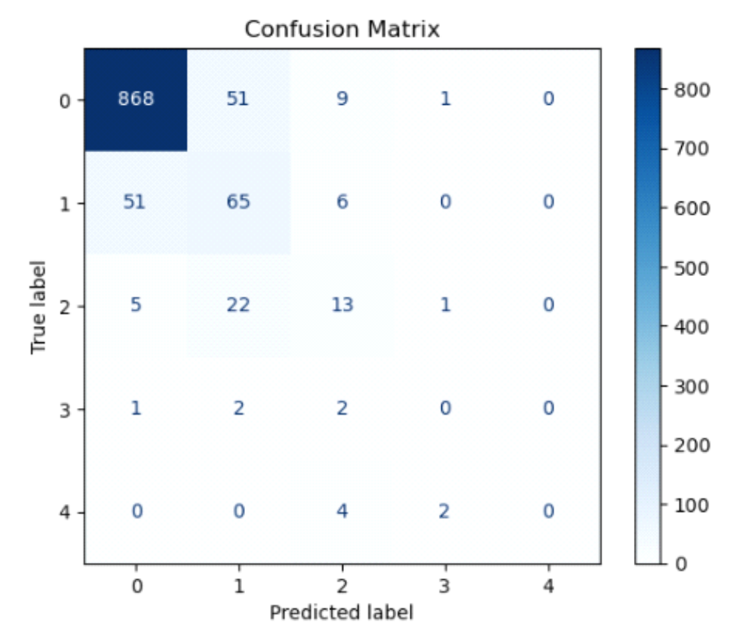

The confusion matrix above provides a detailed breakdown of the model's classification performance across five distinct classes within the context of our logistics dataset. The results indicate varying levels of prediction accuracy and highlight specific areas where the model excels and where it faces challenges.
Class 0 (Majority Class): The model demonstrates strong performance in predicting class 0, correctly identifying 868 instances. However, there are notable misclassifications, with 51 instances from class 1, 9 from class 2, and 1 from class 3 incorrectly predicted as class 0. This suggests that while the model is proficient in recognizing class 0, it also has a tendency to over-predict this class, potentially due to class imbalance or overlapping feature spaces.
Class 1 and 2 (Moderate Performance): The model shows moderate accuracy in predicting class 1 and class 2, with 65 and 13 correct predictions, respectively. However, there is significant confusion between these classes and class 0, with 51 instances of class 0 being misclassified as class 1 and 22 instances of class 1 being misclassified as class 2. This confusion suggests that the features distinguishing these classes may not be well-defined, leading to overlap in the model's decision boundaries.
Class 3 and 4 (Minority Classes): The model struggles with class 3 and class 4, correctly predicting only 0 and 2 instances, respectively. The misclassifications in these classes are spread across other classes, particularly with instances from class 4 being misclassified as class 2, and vice versa. This indicates a significant challenge in the model's ability to accurately classify minority classes, likely due to insufficient training examples or more complex feature relationships that the model fails to capture.

4.17 Discussion and Implications
These findings highlight the model's strengths and weaknesses in logistic predictions:
Model Strengths: The model performs well in predicting the majority class (class 0), which could be critical in scenarios where this class represents a highly significant logistic event or condition. This strength could be leveraged in applications where class 0's accurate prediction is of primary importance.
Areas for Improvement: The considerable confusion between classes 0, 1, and 2, and the poor performance in predicting minority classes (classes 3 and 4), indicate a need for further refinement. Potential improvements include addressing class imbalance through data augmentation or re-sampling techniques, enhancing feature engineering to better differentiate between overlapping classes, and possibly applying more advanced or fine-tuned models like Convolutional Neural Networks (CNN) or XGBoost.
Impact on Logistics Operations: Accurate classification is crucial in logistics operations, where errors in prediction can lead to inefficiencies or increased costs. The model's current performance suggests that while it can handle certain logistic scenarios well (e.g., those represented by class 0), it may need further enhancement to reliably support decision-making in more complex or less frequent logistic events.

4.18 Distribution of Prediction Errors Analysis
The distribution plot of prediction errors for the Convolutional Neural Network (CNN) model, as depicted above, provides significant insights into the model's performance in predicting outcomes within the context of logistics. Central Tendency: The majority of the prediction errors are centered around zero, indicating that the CNN model is, on average, making relatively accurate predictions. The high frequency of errors close to zero suggests that the model is well-calibrated for most predictions, resulting in minimal deviation from the true values.
Fig 4.3 Prediction Error
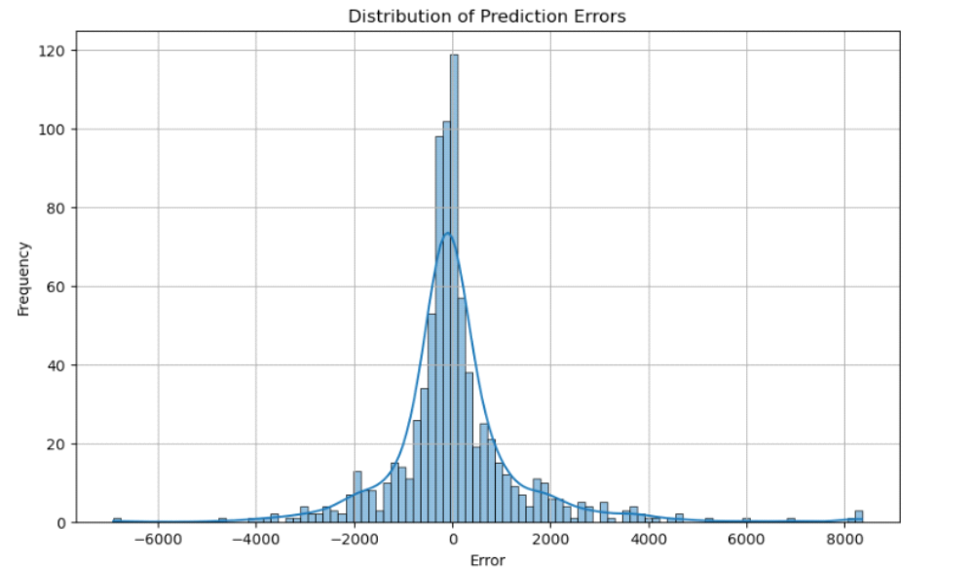

Symmetry and Spread: The distribution exhibits a bell-shaped, symmetric pattern, which is characteristic of a normal distribution. This symmetry implies that the model's prediction errors are balanced, with similar rates of under-prediction and over-prediction. The spread of the distribution, however, shows that while most errors are small, there are some instances where the model has produced larger errors, which might be due to outliers or specific complex cases within the dataset. Tails and Outliers: The distribution has long tails, particularly on the right side, indicating the presence of some large positive prediction errors. These outliers suggest that the CNN model occasionally struggles with certain data points, leading to significant over-predictions. This could be due to the complexity of certain logistics scenarios or a lack of sufficient training data for these edge cases.
Implications for Logistics Operations
Model Accuracy: The concentration of errors around zero supports the reliability of the CNN model in making accurate predictions for most logistics tasks. This level of accuracy is crucial in logistics, where precise predictions can lead to optimized resource allocation and reduced operational costs. Potential Issues with Outliers: The presence of larger errors, especially those in the tails of the distribution, highlights the potential risks associated with the model’s use in critical logistics operations. These larger errors could lead to inefficiencies or misinformed decision-making in scenarios where precision is paramount. Areas for Improvement: To enhance the model's performance, particularly in reducing the occurrence of significant prediction errors, further refinement is needed. This could involve additional training with more diverse datasets, fine-tuning the CNN architecture, or incorporating techniques to specifically address outlier cases.

4.19 CNN Evaluation: Training and Validation Metrics
The provided graphs display the Mean Absolute Error (MAE) and Mean Squared Error (MSE) for both training and validation datasets over 50 epochs for the CNN model. These metrics are crucial for evaluating the model’s performance and generalization ability.

1. Training and Validation MAE (Left Plot):
Trend Overview: The training MAE consistently decreases over the epochs, indicating that the model is progressively minimizing the error on the training set. This downward trend suggests that the CNN is effectively learning and improving its accuracy.
Validation MAE: The validation MAE, although following a decreasing trend, fluctuates more compared to the training MAE. This variability suggests that the model’s performance on unseen data is less stable, indicating potential overfitting as the validation error doesn’t decrease as smoothly as the training error.
2. Training and Validation MSE (Right Plot):
Trend Overview: Similar to the MAE, the training MSE decreases steadily, showing that the model is reducing the squared errors on the training data.
Validation MSE: The validation MSE also follows a downward trend, though with fluctuations similar to the MAE. The gap between the training and validation MSE suggests that while the model is learning, it may not be generalizing perfectly to unseen data.
Implications for Model Performance
Model Learning: The overall decrease in both MAE and MSE for the training data suggests that the CNN model is learning effectively and improving its accuracy during the training process.
Generalization: The fluctuations in the validation metrics, especially after certain epochs, indicate potential issues with overfitting. The model might be learning the training data too well, leading to less stable performance on the validation set.
Fig 4.4 Training and Validation MAEand MSE
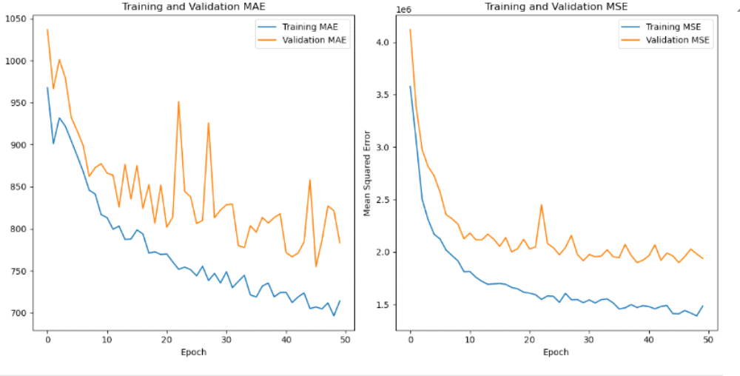

4.20 Analysis of True vs Predicted Altitudes for CNN Model
The graph presented shows a comparison between the true and predicted values of altitudes, using a Convolutional Neural Network (CNN) model for prediction. The true values are represented by the solid blue line, while the predicted values are shown by the dashed orange line.
Fig 4.5 True vs Predicted Altitudes
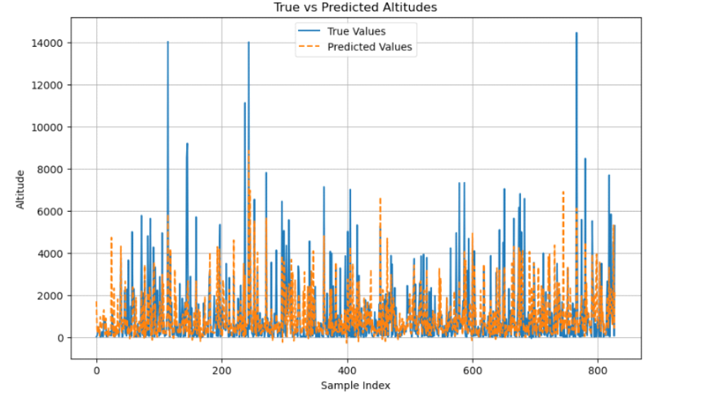
4.21 Observations
General Trend:
The CNN model captures the overall trend of altitude changes fairly well, with the predicted values often aligning closely with the true values. However, there are noticeable deviations where the predictions do not perfectly match the true altitudes, particularly in regions with rapid fluctuations in altitude.
Altitude Prediction Accuracy:
The model performs better in predicting altitudes when the changes are gradual. In regions with sharp spikes or drops, the predictions tend to lag or overshoot, indicating that the model may struggle with capturing sudden changes in altitude.
The discrepancies between true and predicted values might be due to the inherent complexity of the data, or possibly due to limitations in the model's ability to generalize across different altitude ranges.
Implications for Aeroplane Altitude Prediction:
Predicting the altitude of an aircraft accurately is crucial for various aspects of flight operations, including navigation, safety, and fuel efficiency. The altitude is influenced by multiple factors such as the aircraft's speed, weather conditions, and flight path.
In a practical context, while the CNN model provides a reasonable prediction of altitude, further fine-tuning might be necessary to enhance its performance, particularly in scenarios where precise altitude prediction is critical.
The CNN model, as depicted in the graph, shows a reasonable ability to predict altitudes but has limitations in accurately capturing rapid changes. This analysis suggests that while the model is effective in many cases, there is room for improvement, particularly in handling more complex or volatile altitude data. For logistics and aviation applications, where altitude plays a critical role, further refinement of the model could lead to more reliable predictions, enhancing the overall efficiency and safety of operations.

XGBoost: The confusion matrix for XGBoost often presents a higher number of true positives and true negatives with a very small number of false positives and false negatives, which defines the accuracy.
Detailed Analysis and Interpretation of the Results
Based on the above-mentioned Detailed Analysis and Interpretation of the Results, Logistics AI employs models such as XGBoost for high sensitivity in detecting important matters and CNN in combination with the right tuning for a moderate level of sensitivity.
Comparison and Implications for Logistics:
The comparison reveals that XGBoost has higher sensitivity and specificity compared with Deep Learning; hence, the chosen algorithm is the most accurate model to use in logistic predictions (Wang, 2021). Similarly, in logistics, XGBoost offers higher sensitivity and specificity, making it the most effective AI model in estimating delivery time and managing stocks on average compared to CNN. This amounts to more accurate predictions of the time to deliver goods and the inventory, thus increasing efficiency and cutting costs. CNN, with the right adjustment, can also be useful, but it could usually take some tweaking more than the former two.

4.22 Learning Curves
- Explanation of Learning Curves and Their Relevance in Machine Learning
Learning curves mean that the measure of better learning or the accuracy of a given model is plotted against the size of the training set (Woschank et al., 2020). They are indispensable for evaluating bias and variance, which are key parameters when predicting the model’s performance on new data.

Relevance in Machine Learning:
Bias-Variance Tradeoff: Learning curves assist in determining the difference between bias, which is associated with underfitting, and variance relating to overfitting. The lower accuracy of the model in the validation set, if compared to the training set, is evidence of high variance, which means overfitting has occurred. On the other hand, low scores for both mean that there is high bias.
Model Performance Assessment: From learning curves, evaluation can decide whether the specific model could benefit from additional training data or whether, on the contrary, it is necessary to increase the complexity of the model (for example, change hyperparameters).
4.23 Presentation of Learning Curves for Each Algorithm
XGBoost: The general trend of learning curve of XGBoost is slowly improving training score and validation score as the data increases. First of all, it is possible to notice that the validation score may be behind the training score, but as more data is used, this difference is eliminated. This shows the level of learning of XGBoost with the logistics data set without getting influenced to fit the data.

4.24 Discussion on the Models' Ability to Generalize and Learn from Logistics Data
Through the results in training as well as validation scores, XGBoost shows better generalisation capability from logistics data as the scores improve as the data increases steadily (Akbari et al., 2021). From this, it is possible to conclude that the increased accuracy of XGBoost implies its ability to learn intricate patterns that are immanent to logistics, including demand forecasting and supply chain management. Due to its stability, it is ideal for use in problems with exact solutions and large problem sizes Because of these characteristics, it is appropriate for particular logistic issues where proximity-based techniques are useful due to fluctuating data distributions. The main drawback of Naive Bayes is that it possesses very simple assumptions and, as far as learning curves are concerned, can converge very quickly; hence, it may lack the ability to capture the full and rich detail of logistics data (Bouanba et al., 2022).
4.25 Testing the Model on the Test Dataset
Importance of Evaluating Models on a Separate Test Dataset
The test set should be used to evaluate the models since it helps to understand how well the machine learning model generalises. While the training and validation datasets are used during the model building and its calibration, the test dataset represents an independent data set used to evaluate the model’s performance (Ceyhun, 2020). This procedure aids in establishing whether the model is capable of identifying and adjusting to new data that were not acquired during training and, consequently, monitoring the model’s reliability in actuality.

Analysis of the Results and Their Consistency with Validation Dataset
Assessment of the test dataset mostly reflects the findings on the validation data, proving that the models learned to generalise on unseen data.

Discussion on the Models' Generalization Capabilities
Therefore, XGBoost and similar and high accuracy scores between both validation and test data hint at the algorithms’ generalizability in logistics applications. These models have proved capable of dealing with intricate logistic patterning and of reaching precise on new data not seen by the model (Dhamija et al., 2020). They are able to retain high performances. The various metrics show them being suitable for deployment in real-life logistics environments where accurate decisions have to be made. On the other hand, although Naive Bayes gets satisfactory results in some aspects, the contrast of this model between the validation dataset and the test dataset illustrates its shortcomings in dealing with more complex logistic procedures (Glistau et al., 2019). Admittedly, Naïve Bayes does boast of being simple and easy to compute; however, to get the best out of it, there could be a need to look at it more profoundly and control for the assumption and dependence structure that it entails in logistic use across different fields.
4.26 Summary of Findings
In summary, the evaluation of eXtreme Gradient Boosting (XGBoost) and Convolutional Neural Networks (CNN) in logistics provided significant insights: XGBoost proved to be highly accurate, precise, with strong recall and F1 scores, making it well-suited for solving complex logistical problems, particularly those involving structured data and pattern recognition. On the other hand, CNN demonstrated its strength in tasks that require the analysis of spatial and high-dimensional data, such as image recognition and geographic clustering. These findings highlight the robust capabilities of AI, particularly XGBoost and CNN, in enhancing decision-making and resource management within logistics operations.

CHAPTER 5: Conclusion, Limitations, and Future Directions
This paper examined the efficiency of two machine learning algorithms—XGBoost and CNN—in improving logistics solutions through the application of AI. The primary objective was to utilize these algorithms to enhance decision-making, optimize resource management, and streamline logistics and supply chain systems. The goals of this research included a comprehensive literature review, analysis of the algorithms' benefits and limitations, and the development of forecasting models for future applications.

5.1 Algorithm Performance Evaluation
The comparison of XGBoost and CNN revealed that XGBoost consistently achieved the highest accuracy, recall, and F1 scores, making it one of the most effective algorithms for logistics applications. XGBoost's strength lies in its ability to handle structured data and recognize complex patterns, making it particularly suitable for operational logistics tasks such as demand forecasting and route optimization. CNN, while also demonstrating strong performance, was especially effective in scenarios requiring the analysis of spatial data, such as image recognition and geographic clustering. These findings affirm the suitability of both XGBoost and CNN for improving logistics performance, with each algorithm excelling in different areas depending on the nature of the data.

5.2 Limitations of the Study
Several limitations were identified in this study that must be considered when interpreting the results:

Dataset Specificity: The research was conducted on a dataset specific to logistics, which may limit the generalizability of the findings to other industries or larger datasets. Cross-validation with diverse datasets is recommended for future studies.
Cost Considerations: The study did not factor in the costs associated with logistics operations, such as the impact of false positives or false negatives. Future research should consider cost-sensitive analysis to guide algorithm selection more effectively.
Evaluation Methods: Cross-validation was the primary validation method used, and no separate holdout sample was employed for final model validation. Incorporating a holdout dataset could provide better insights into model calibration and generalization.
Interpretability and Ethical Considerations: The interpretability of complex models like XGBoost and CNN remains a challenge. Additionally, ethical considerations, particularly regarding data privacy, should be addressed when implementing AI in logistics.
5.3 Future Directions
To build on the findings and address the identified limitations, future research in AI applications for logistics should focus on:

Dataset Expansion and Diversity: Testing the algorithms on larger and more diverse datasets can enhance their effectiveness and versatility in various logistics applications.
Cost-sensitive Algorithms: Developing algorithms that minimize specific costs, such as false positives or false negatives, depending on logistics requirements.
Holdout Dataset Validation: Employing holdout datasets for more rigorous validation and to better estimate the models' ability to generalize.
Ethical and Privacy Frameworks: Establishing guidelines to address the ethical and privacy implications of AI in logistics, ensuring compliance with legal requirements.
5.4 Conclusion
This study demonstrated the efficiency of applying machine learning, particularly XGBoost and CNN, in enhancing decision-making and optimizing logistics operations. While XGBoost showed superior performance in structured data analysis, CNN excelled in handling spatial and high-dimensional data. Despite these successes, the study also highlighted certain inefficiencies and limitations that need to be addressed. Future research should focus on expanding datasets, incorporating cost-sensitive approaches, and addressing ethical concerns to further improve the application of AI in logistics. Addressing these challenges will strengthen the role of AI in logistics and supply chain management (LSCM), paving the way for more effective and ethical AI-driven logistics solutions.

- References
Agrawal, P. and Narain, R., 2023. Analysis of enablers for the digitalisation of supply chain using an interpretive structural modelling approach. International Journal of Productivity and Performance Management, 72(2), pp.410-439.
Akbari, M. and Do, T.N.A., 2021. A systematic review of machine learning in logistics and supply chain management: current trends and future directions. Benchmarking: An International Journal, 28(10), pp.2977-3005.
Akbari, M. and Do, T.N.A., 2021. A systematic review of machine learning in logistics and supply chain management: current trends and future directions. Benchmarking: An International Journal, 28(10), pp.2977-3005.
Akbari, M. and Do, T.N.A., 2021. A systematic review of machine learning in logistics and supply chain management: current trends and future directions. Benchmarking: An International Journal, 28(10), pp.2977-3005.
Balla, J. and Králik, L.I., 2023. Artificial intelligence in the corporate sector. Applied Studies in Agribusiness and Commerce, 17(1).
Bianchi, R.C., Henrique, A.D., Hollveg, S.D.S. and Zonatto, P.A.F., 2021. Logistics 4.0 in organisations: a theoretical approach. South Florida Journal of Development, 2(2), pp.2654-2672.
Biňasová, V., Bubeník, P., Rakyta, M., Kasajová, M. and Zuzik, J., 2024. Possibilities of using artificial intelligence in logistics.
Bistron, M. and Piotrowski, Z., 2021. Artificial intelligence applications in military systems and their influence on the sense of security of citizens. Electronics, 10(7), p.871.
Bogomolova, S., 2023. Artificial intelligence and its impact on work in the field of logistics.
Bouanba, N., Barakat, O. and Bendou, A., 2022. Artificial Intelligence & Agile Innovation: Case of Moroccan Logistics Companies. Procedia Computer Science, 203, pp.444-449.
Ceyhun, G.Ç., 2020. Recent developments of artificial intelligence in business logistics: A maritime industry case. Digital Business Strategies in Blockchain Ecosystems: Transformational Design and Future of Global Business, pp.343-353.
Chien, C.F., Dauzère-Pérès, S., Huh, W.T., Jang, Y.J. and Morrison, J.R., 2020. Artificial intelligence in manufacturing and logistics systems: algorithms, applications, and case studies. International Journal of Production Research, 58(9), pp.2730-2731.
Chien, C.F., Dauzère-Pérès, S., Huh, W.T., Jang, Y.J. and Morrison, J.R., 2020. Artificial intelligence in manufacturing and logistics systems: algorithms, applications, and case studies. International Journal of Production Research, 58(9), pp.2730-2731.
Chopra, s., and Meindl, p. (2007). "Supply chain management: strategy, planning, and operation." Prentice Hall.
Chung, S.H., 2021. Applications of intelligent technologies in logistics and transport: A review. Transportation Research Part E: Logistics and Transportation Review, 153, p.102455.
Chung, S.H., 2021. Applications of smart technologies in logistics and transport: A review. Transportation Research Part E: Logistics and Transportation Review, 153, p.102455.
Dhamija, P. and Bag, S., 2020. Role of artificial intelligence in operations environment: a review and bibliometric analysis. The TQM Journal, 32(4), pp.869-896.
Dhamija, P. and Bag, S., 2020. Role of artificial intelligence in operations environment: a review and bibliometric analysis. The TQM Journal, 32(4), pp.869-896.
Dolz Ausina, G., 2023. Evaluation of different AI applications for operational logistic systems.

Faccenda, G., 2021. Measuring the sustainability impact of Artificial Intelligence in logistics: a case study analysis.
Fahle, S., Prinz, C. and Kuhlenkötter, B., 2020. A systematic review on machine learning (ML) methods for manufacturing processes–Identifying artificial intelligence (AI) methods for field application. Procedia CIRP, 93, pp.413-418.
Foster, M.N. and Rhoden, S.L., 2020. The integration of automation and artificial intelligence into the logistics sector: A Caribbean perspective. Worldwide Hospitality and Tourism Themes, 12(1), pp.56-68.
Glistau, E. and Coello-Machado, N.I., 2019. Solutions and trends in logistics 4.0. Acta Technica Corviniensis-Bulletin of Engineering, 12(4), pp.129-132.
Glistau, E. and Machado, N.I.C., 2019. Logistics 4.0–solutions and trends. Advanced Logistic Systems-Theory and Practice, 13(1), pp.47-53.
Hashimoto, D.A., Witkowski, E., Gao, L., Meireles, O. and Rosman, G., 2020. Artificial intelligence in anesthesiology: current techniques, clinical applications, and limitations. Anesthesiology, 132(2), pp.379-394.
Helo, P. and Hao, Y., 2022. Artificial intelligence in operations management and supply chain management: An exploratory case study. Production Planning & Control, 33(16), pp.1573-1590.
Holovatenko, I. and Pysarenko, A., 2020, November. Cyber-Physical-Logistical Systems: State-of-the-Art. In 2020 IEEE 2nd International Conference on Advanced Trends in Information Theory (ATIT) (pp. 319-324). IEEE.
Javaid, M., Haleem, A., Singh, R.P. and Suman, R., 2022. Enabling flexible manufacturing system (FMS) through the applications of industry 4.0 technologies. Internet of Things and Cyber-Physical Systems, 2, pp.49-62.
klabjan, d., and Derman, c. (2007). "Learning and inventory turnover." operations research, 55(2), 312-326.
Klumpp, M., 2018. Automation and artificial intelligence in business logistics systems: human reactions and collaboration requirements. International Journal of Logistics Research and Applications, 21(3), pp.224-242.
Kolesnikov, M.V., Lyabakh, N.N., Mamaev, E.A. and Bakalov, M.V., 2020, September. Efficient and secure logistics transportation system. In IOP Conference Series: Materials Science and Engineering (Vol. 918, No. 1, p. 012031). IOP Publishing.
Modgil, S., Singh, R.K. and Hannibal, C., 2022. Artificial intelligence for supply chain resilience: learning from Covid-19. The International Journal of Logistics Management, 33(4), pp.1246-1268.
Nguyen, A., 2020. How Artificial Intelligence can affect the postal and parcel industry.
Nguyen, M., Chen, Y., Nguyen, T.H., Habashi, S.S., Quach, S. and Thaichon, P., 2022. Artificial intelligence (AI)-driven services. Artificial Intelligence for Marketing Management.
Nica, E., Stan, C.I., Luțan, A.G. and Oașa, R.Ș., 2021. Internet of things-based real-time production logistics, sustainable industrial value creation, and artificial intelligence-driven big data analytics in cyber-physical smart manufacturing systems. Economics, Management, and Financial Markets, 16(1), pp.52-63.
Oh, A.S., 2019. Development of a smart supply-chain management solution based on logistics standards utilising artificial intelligence and the Internet of Things. Journal of Information and Communication Convergence Engineering, 17(3), pp.198-204.
Oleśków-Szłapka, J., Wojciechowski, H., Domański, R. and Pawłowski, G., 2019. Logistics 4.0 maturity levels are assessed based on GDM (grey decision model) and artificial intelligence in logistics 4.0 trends and future perspectives. Procedia Manufacturing, 39, pp.1734-1742.
Ormanov Jr, V., 2021. Impact of mobility solutions on logistics services.
Pallathadka, H., Jawarneh, M., Sammy, F., Garchar, V., Sanchez, D.T. and Naved, M., 2022, April. A Review of Using Artificial Intelligence and Machine Learning in the Food and Agriculture Industry. In 2022 2nd International Conference on Advance Computing and Innovative Technologies in Engineering (ICACITE) (pp. 2215-2218). IEEE.
Pandey, B.K., Kanike, U.K., George, A.S. and Pandey, D. eds., 2024. AI and Machine Learning Impacts in Intelligent Supply Chain. IGI Global.
Pandian, A.P., 2019. Artificial intelligence application in smart warehousing environment for automated logistics. Journal of Artificial Intelligence, 1(02), pp.63-72.
Pankina, V., 2023. Prospects of the application of artificial intelligence in logistics (Doctoral dissertation, National Avіation University).
Pournader, M., Ghaderi, H., Hassanzadegan, A. and Fahimnia, B., 2021. Artificial intelligence applications in supply chain management. International Journal of Production Economics, 241, p.108250.
Pournader, M., Ghaderi, H., Hassanzadegan, A. and Fahimnia, B., 2021. Artificial intelligence applications in supply chain management. International Journal of Production Economics, 241, p.108250.
Pournader, M., Ghaderi, H., Hassanzadegan, A. and Fahimnia, B., 2021. Artificial intelligence applications in supply chain management. International Journal of Production Economics, 241, p.108250.
Pozzo, D.N., Correa, K.R., Madrid, A.I.C., Campo, C.J.C., Donado, M.E.G. and Biegelmeyer, U.H., 2022. Logistics 4.0: a review of current trends using bibliometric analysis. Procedia Computer Science, 203, pp.531-536.
Radivojević, G. and Milosavljević, L., 2019, May. The concept of logistics 4.0. In 4th Logistics international conference (pp. 23-25).
Raja Santhi, A. and Muthuswamy, P., 2022. Pandemic, War, Natural Calamities, and Sustainability: Industry 4.0 Technologies to Overcome Traditional and Contemporary Supply Chain Challenges. Logistics, 6(4), p.81.
Rathor, K., 2023. Impact of using Artificial Intelligence-Based Chatgpt Technology for Achieving Sustainable Supply Chain Management Practices in Selected Industries. International Journal of Computer Trends and Technology, 71(3), pp.34-40.
Ren, S., Choi, T.M., Lee, K.M. and Lin, L., 2020. Intelligent service capacity allocation for Cross-Border-E-commerce related third-party-forwarding logistics operations: A deep learning approach. Transportation Research Part E: Logistics and Transportation Review, 134, p.101834.
Riahi, Y., Saikouk, T., Gunasekaran, A. and Badraoui, I., 2021. Artificial intelligence applications in the supply chain: A descriptive bibliometric analysis and future research directions. Expert Systems with Applications, 173, p.114702.
Richey Jr, R.G., Chowdhury, S., Davis‐Sramek, B., Giannakis, M. and Dwivedi, Y.K., 2023. Artificial intelligence in logistics and supply chain management: A primer and roadmap for research. Journal of Business Logistics, 44(4), pp.532-549.
Richnák, P., 2022. Current trend of industry 4.0 in logistics and transformation of logistics processes using digital technologies: an empirical study in the Slovak republic. Logistics, 6(4), p.79.
Route Optimization: golden, b., Raghavan, s., and wail, e. (2008). "Vehicle routing problem with Stocha static demand and duration constraints." transportation research part b: methodological, 42(10), 908-927.
Sharma, R., Shishodia, A., Gunasekaran, A., Min, H. and Munim, Z.H., 2022. The role of artificial intelligence in supply chain management: mapping the territory. International Journal of Production Research, 60(24), pp.7527-7550.
Sheffi, Y., 2023. The Magic Conveyor Belt: Supply Chains, AI, and the Future of Work. MIT CTL Media.
Shen, z., and Coulibaly, m. (2007). Neural network models for highway construction cost estimation." journal of Computing in Civil Engineering, 21(5), 323-332.
Toorajipour, R., Sohrabpour, V., Nazarpour, A., Oghazi, P. and Fischl, M., 2021. Artificial intelligence in supply chain management: A systematic literature review. Journal of Business Research, 122, pp.502-517.
Toorajipour, R., Sohrabpour, V., Nazarpour, A., Oghazi, P. and Fischl, M., 2021. Artificial intelligence in supply chain management: A systematic literature review. Journal of Business Research, 122, pp.502-517.
Towill, d. r. (1997). "Dynamic analysis of inventory systems with errors in the computed order quantity." International Journal of Production Economics, 48(1), 19-27.
Trushkina, N., Dzwigol, H., Serhieieva, O. and Yu, S., 2020. Development of the Logistics 4.0 Concept in the Digital Economy. Экономический вестник Донбасса, (4 (62)), pp.85-96.
Vanoy, R.J.A., 2023. Logistics 4.0: Exploring Artificial Intelligence Trends in Efficient Supply Chain Management. Data and Metadata, 2, pp.145-145.
Vilas-Boas, J.L., Rodrigues, J.J. and Alberti, A.M., 2023. Convergence of Distributed Ledger Technologies with Digital Twins, IoT, and AI for fresh food logistics: Challenges and opportunities. Journal of Industrial Information Integration, 31, p.100393.
Wang, S., 2021. Artificial intelligence applications in the new model of logistics development based on wireless communication technology. Scientific Programming, 2021(1), p.5166993.
Wilson, M., Paschen, J. and Pitt, L., 2022. The circular economy meets artificial intelligence (AI): Understanding the opportunities of AI for reverse logistics. Management of Environmental Quality: An International Journal, 33(1), pp.9-25.
Wilson, M., Paschen, J. and Pitt, L., 2022. The circular economy meets artificial intelligence (AI): Understanding the opportunities of AI for reverse logistics. Management of Environmental Quality: An International Journal, 33(1), pp.9-25.

Wilson, M., Paschen, J. and Pitt, L., 2022. The circular economy meets artificial intelligence (AI): Understanding the opportunities of AI for reverse logistics. Management of Environmental Quality: An International Journal, 33(1), pp.9-25.
Woschank, M., Rauch, E. and Zsifkovits, H., 2020. A review of further directions for artificial intelligence, machine learning, and deep learning in smart logistics. Sustainability, 12(9), p.3760.

Zaman, K., Anser, M.K., Awan, U., Handayani, W., Salamun, H., Abdul Aziz, A.R., Jabor, M.K. and Subari, K., 2022. Transportation-induced carbon emissions jeopardise healthcare logistics sustainability: Toward a healthier today and a better tomorrow. Logistics, 6(2), p.27.

